**Introduction Oracle SQL and PL/SQL**

**Module 1/Day 1**

SELECT Statement:

1. **List tables in your schema and check for existence of DEPT, EMP and SALGERADE tables**

SELECT TABLE_NAME FREOM USER_TABLES;--If we have admin access

SELECT OWNER,TABLE_NAME FROM ALL_TABLES;

SELECT * FROM SCOTT.DEPT;

SELECT * FROM SCOTT.EMP;

SELECT *FROM SCOTT. SALGERADE;

1. **If these tables do NOT exists – execute the script in the embedded DemoBld.SQL file to create and populate the tables .**

Executed given script.

1. **List all columns and all rows from DEPT**

SELECT * FROM DEPT;

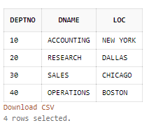

1. List all columns and all rows from EMP

SELECT * FROM EMP;

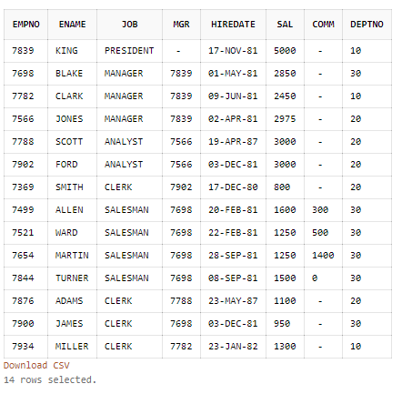

1. **List all columns and all rows from SALGRADE**

SELECT *FROM SCOTT. SALGRADE;

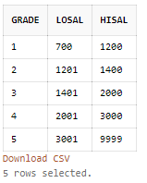

1. **List employee number, name and salary from employee table**

SELECT EMPNO,ENAME,SAL FROM SCOTT.EMP;

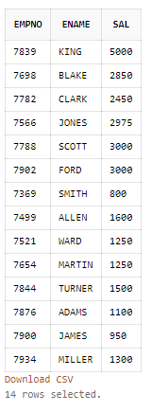

1. **List employee number, name and salary from employee table where salary is > 3000**

SELECT EMPNO,ENAME,SAL FROM SCOTT.EMP

WHERE SAL>3000;

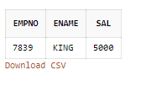

1. List employees joined after year 1981

SELECT * FROM SCOTT.EMP e

WHERE e.HIREDATE > '31-DEC-1981' ;

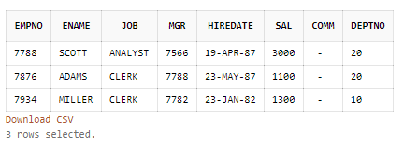

1. List all clerks (JOB = ‘CLERK’)

SELECT * FROM SCOTT.EMP e WHERE e.JOB='CLERK' ;

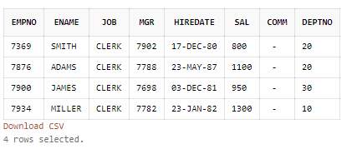

1. List employees in the ascending order of salary

SELECT * FROM SCOTT.EMP ORDER BY SAL ;

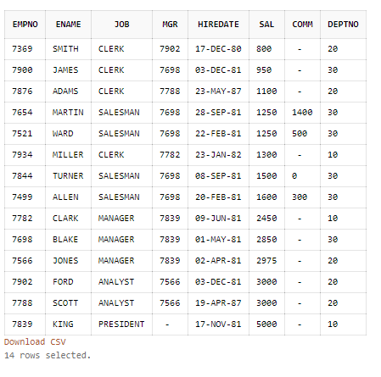

1. List employees in ascending order of job within descending order of deptno

SELECT * FROM SCOTT.EMP ORDER BY JOB , DEPTNO DESC ;

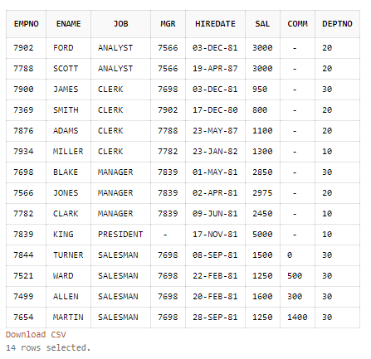

1. List distinct departments from employee table

SELECT DISTINCT DEPTNO FROM SCOTT.EMP;

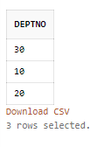

1. List distinct jobs in each department from employee table

SELECT DISTINCT JOB FROM SCOTT.EMP GROUP BY JOB,DEPTNO

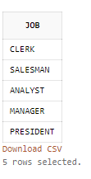

1. List name, salary and annual salary in the descending order of annual salary – annual salary is a computed column – SAL * 12

SELECT ENAME,SAL. 12*SAL AS ANNUAL_SALARY FROM SCOTT.EMP ORDER BY

ANNUAL_SALARY DESC;

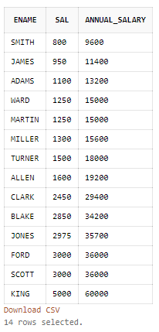

15. List employees whose salary is not in the range of 2000 and 3000

SELECT * FROM SCOTT.EMP

WHERE SAL NOT IN(2000,3000);

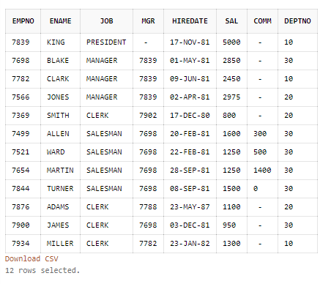

1. List name and the deptno for all employees who are NOT members of departments 10 and 20

SELECT ENAME,DEPTNO FROM SCOTT.EMP

WHERE DEPTNO NOT IN(10,20);

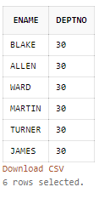

1. List name and the deptno for all employees who are NOT members of departments 10 and 20

SELECT * FROM SCOTT.EMP

WHERE DEPTNO NOT IN (10,20);

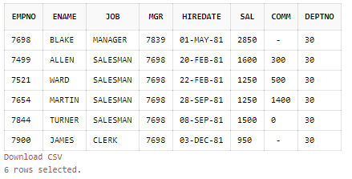

1. List employees for whom COMM is not applicable

SELECT * FROM SCOTT.EMP

WHERE COMM IS NULL;

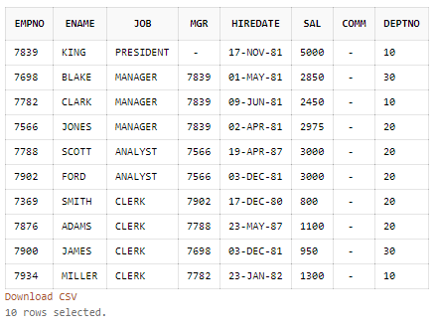

1. List employees for whom COMM is applicable

SELECT * FROM SCOTT.EMP

WHERE COMM IS NOT NULL;

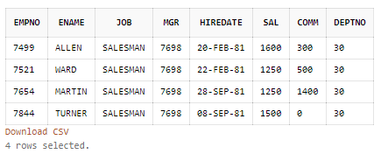

1. List employees in ascending order of COMM and note how NULLs are sorted

SELECT * FROM SCOTT.EMP

WHERE COMM IS NOT NULL ORDER BY COMM ;

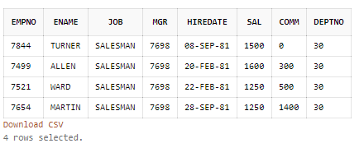

1. List employees whose names start with ‘’SMITH’

SELECT * FROM SCOTT.EMP

WHERE ENAME LIKE 'SMITH%' ;

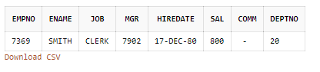

1. List employees whose name contain the ‘MI’

SELECT * FROM SCOTT.EMP

WHERE ENAME LIKE '%MI%';

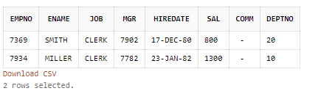

1. List employees whose name start with an _ (underscore) char.

SELECT * FROM SCOTT.EMP

WHERE ENAME LIKE '_%';

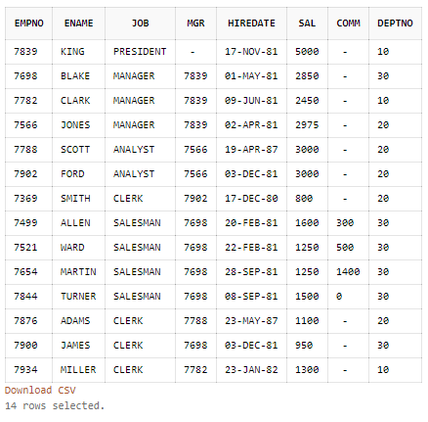

1. List all employees joined between two given dates.

SELECT * FROM SCOTT.EMP WHERE HIREDATE BETWEEN TO_DATE ('17-12-1980' ,'dd-mm-yyyy') AND TO_DATE ('17-11-1981' ,'dd-mm-yyyy'); 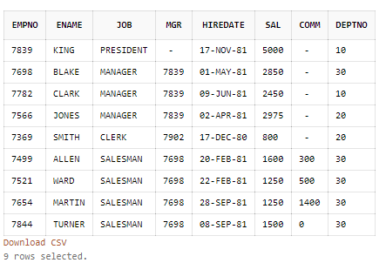

1. List all clerks in deptno 10

SELECT * FROM SCOTT.EMP

WHERE JOB = 'CLERK' AND DEPTNO =10;

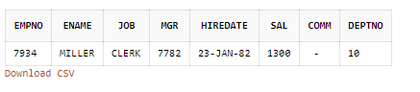

1. List total/sum, maximum, minimum, average of salary from employee table

SELECT SUM(SAL) AS TOTALSAL, MAX(SAL) AS MAXSALARY, MIN(SAL) MINSAL,AVG(SAL) AVGSAL FROM SCOTT.EMP;

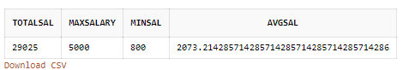

1. List average and count of commission of all employees in department 10

SELECT AVG(COMM) AVG,COUNT(COMM) FROM SCOTT.EMP

WHERE DEPTNO=10;

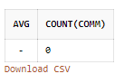

1. List department wise no of employees and total salary

SELECT DEPTNO,SUM(SAL) TOTALSALARY FROM SCOTT.EMP

GROUP BY DEPTNO;

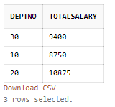

1. List total salary Job wise within each department

SELECT DEPTNO,JOB,SUM(SAL) TOTALSALARY FROM SCOTT.EMP

GROUP BY DEPTNO,JOB;

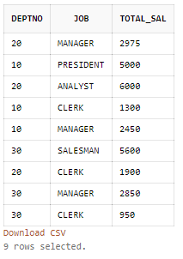

1. List department wise total salary for deptno 10 and 20 only

SELECT DEOTNO,SUM(SAL) TOTALSALARY FROM SCOTT.EMP

WHERE DEPTNO IN(10,20)

GROUP BY DEPTNO;

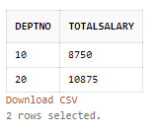

1. List department wise total salary where total salary is > 6000

SELECT DEPTNO,SUM(SAL) TOTALSAL FROM SCOTT.EMP

WHERE SUM(SAL) > 6000

GROUP BY DEPTNO;

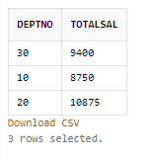

1. SELECT COUNT(*), COUNT(COMM) FROM EMP; - explain why the two counts are different

COUNT(*) : Gives total number of rows present in Emp table.

COUNT(COMM): Ii gives count of total number of non null comm rows in EMP table.

Sub Query:

1. List employees whose job is same as that of ‘SMITH’

SELECT * FROM EMP

WHERE JOB = (SELECT JOB FROM EMP WHERE ENAME=’SMITH’)

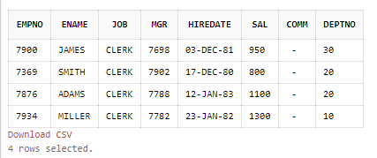

1. List employees who have joined after ‘ADAM’

SELECT * FROM EMP WHERE HIREDATE = (SELECT HIREDATE FROM EMP WHERE ENAME=’ADAM’)



1. List employees who salary is greater than ‘SCOTT’s salary

SELECT * FROM EMP

WHERE SAL> (SELECT SAL FROM EMP WHERE ENAME=’SCOTT’)

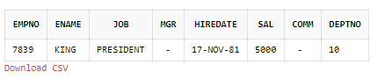

1. List employees getting the maximum salary

SELECT *FROM EMP ORDER BY SAL DESC

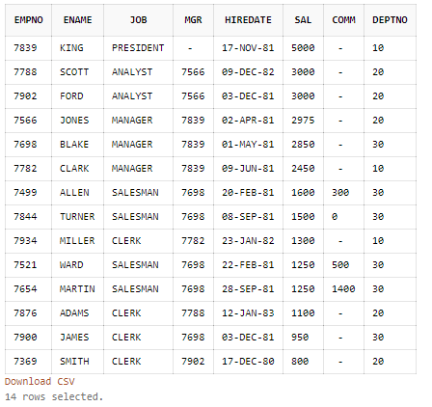

1. List employees show salary is > the max salary of all employees in deptno 30

SELECT * FROM EMP

WHERE SAL> (SELECT MAX(SAL) FROM EMP WHERE DEPTNO=30)

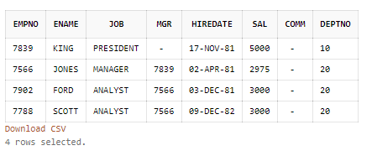

1. List all employees whose deptno and Job are same as that of employee with empno 7788.

SELECT * FROM EMP WHERE DEPTNO= (SELECT DEPTNO FROM EMP WHERE EMPNO=7788)

AND JOB= (SELECT JOB FROM EMP WHERE EMPNO=7788)

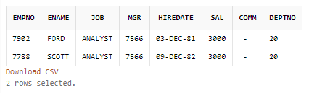

1. List employee who are not managers

SELECT * FROM EMP WHERE JOB NOT IN ‘MANAGER’

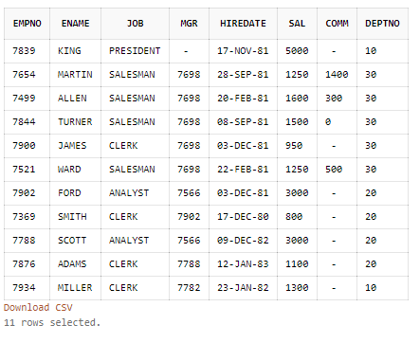

1. List all managers

SELECT * FROM EMP WHERE JOB=’MANAGER’

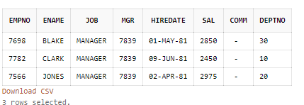

1. List all employees who earn(salary) more than the average salary in their own department

SELECT * FROM EMP

WHERE SAL > 2916.666666666666666666666666666666666667

AND DEPTNO = 10

UNION

SELECT * FROM EMP

WHERE SAL> 2175

AND DEPTNO = 20

UNION

SELECT * FROM EMP

WHERE SAL>1566.666666666666666666666666666666666667

AND DEPTNO = 30

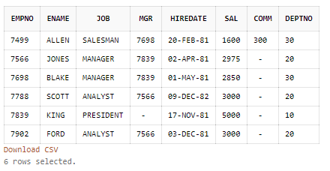

10. List employees whose salary is greater than their manager’s salary

SELECT * FROM EMP WHERE SAL> All(SELECT SAL FROM EMP WHERE JOB=’MANAGER’)

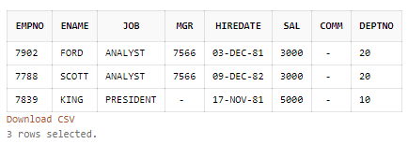

11. List details of departments from DEPT table for which there are no employees in EMP table

SELECT * FROM DEPT WHERE DEPTNO NOT IN(SELECT DEPTNO FROM EMP)

